Notice of Instruction  5905 Breckenridge Parkway, Suite F  Tampa, Florida 33610  (813) 740-3888  (800) 336-2226 (FL)  Fax (813) 623-1342 | 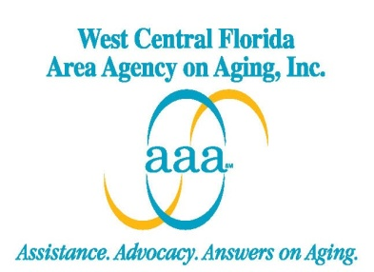

Notice of Instruction Number: 051413 -2013 Co-Pay Information-cw

TO: All Lead Agencies

FROM: Christy Wright, Program Manger

DATE: May 14, 2013

SUBJECT: 2013 Co-Pay Information

_________________________________________________________________________
The purpose of this Notice of Instruction is to provide WCFAAA’s Lead Agencies with the updated information for determining the 2013 co-pay assessment for clients receiving Community Care for the Elderly (CCE) and Alzheimer’s Disease Initiative (ADI) services. The source for the co-pay criteria is the SSI-Related Programs Financial Eligibility Standards: April 2013, posted on the Department of Children and Families’ web site at:

http://www.dcf.state.fl.us/programs/access/docs/ssifactsheet.pdf

The following attachments are included with this notice:

▪ 2013 Community Care for the Elderly (CCE) and Alzheimer’s Disease Initiative (ADI) co-pay schedules for individuals and couples (Attachment A).

▪ Co-pay financial worksheet and assessed co-pay form (Attachment B).

▪ Financial worksheet instructions (Attachment C).

It is necessary this information is immediately sent to your staff to ensure implementation and compliance with the use of the updated co-pay documents.

WCFAAA appreciates your prompt attention and cooperation in regards to this directive. Thank you for your continued commitment to Florida’s elders. Should you require additional program information, please contact your WCFAAA Program Manager.

Attachments

